The following topics must be attached:

1. Brief description of the research/project.

* Engineering a high frequency hygrometer, by making use of an infrared laser. Via absorption of the water molecules in the air the intensity of the laser pulse will be reduced.

2. Floor plan to scale of the space.

* 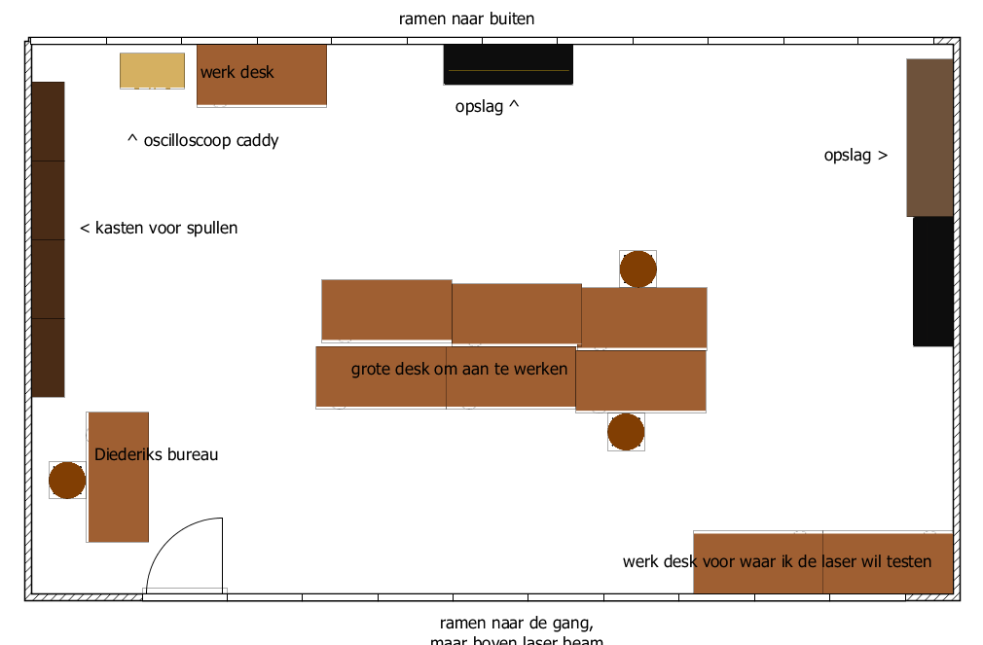
* 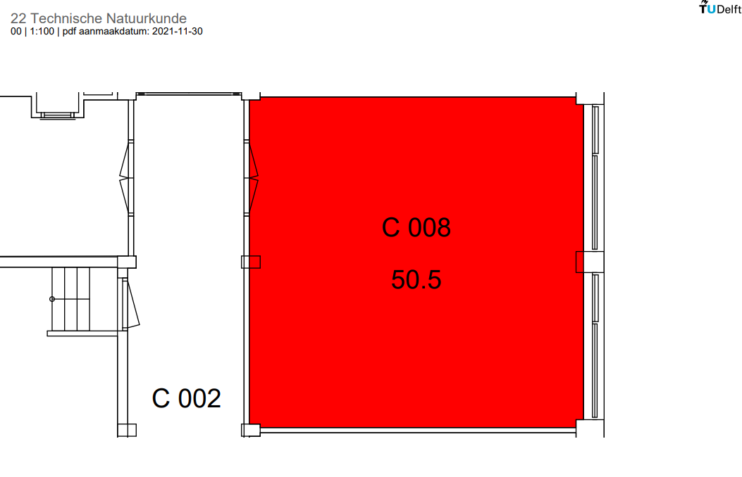

3. Scale plan of the table on which the laser is placed (including all beam paths).

* 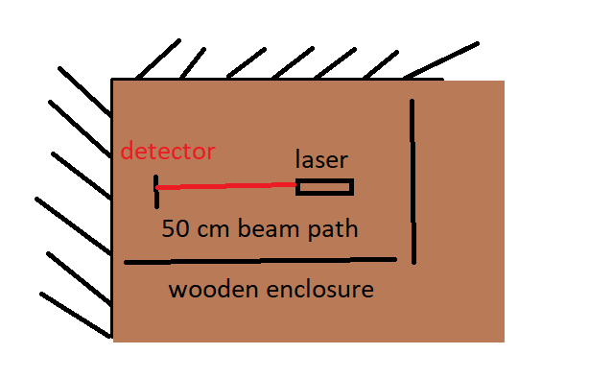

4. Operating instructions for the laser.

* Laser is being powered by a 3 Volt arduino output, making use of a second resistor to control the current.
* Keep it below typical eye-height. Make sure the beam path is secure.

5. Appointments for laser experiment.

* Appointments in C008 of Building 22 Applied Physics.

6. Laser risk analysis (use Laser Safety Checklist).

* Laser is class 3B
* Laser can be turned off by depowering the arduino or decoupling the laser
* Appropriate goggles are not on site yet

7. Risk analysis workspace.

* There is no way any passers by can be hit by direct laser light.
* There are some windows, but none of them are at laser height
* Laser setup will be surrounded by wooden plates
* Laser will be places below eye level

8. List of laser workers.

* Mark Melotto